Great — this is exactly how a strong ERP should be designed 👍
Let’s go step by step, focused on Technical Textiles first, in a way you can directly convert into ERP modules + FSD.

🧵 1. What is Technical Textile?
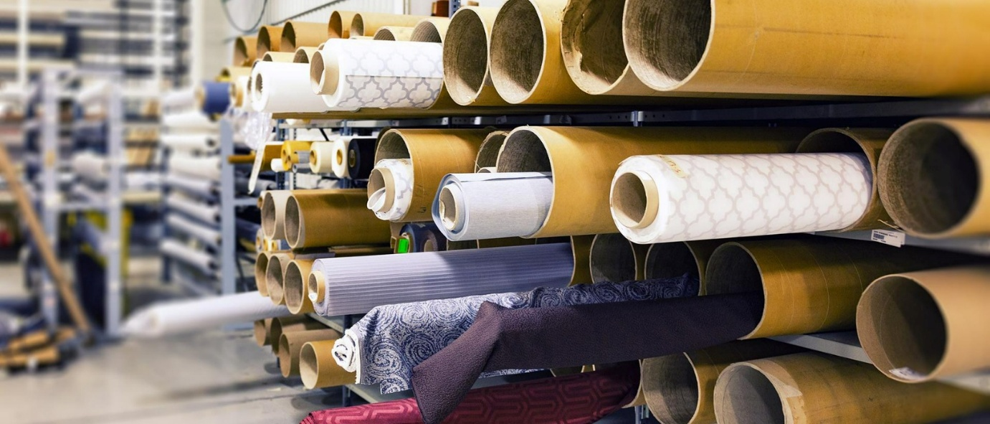

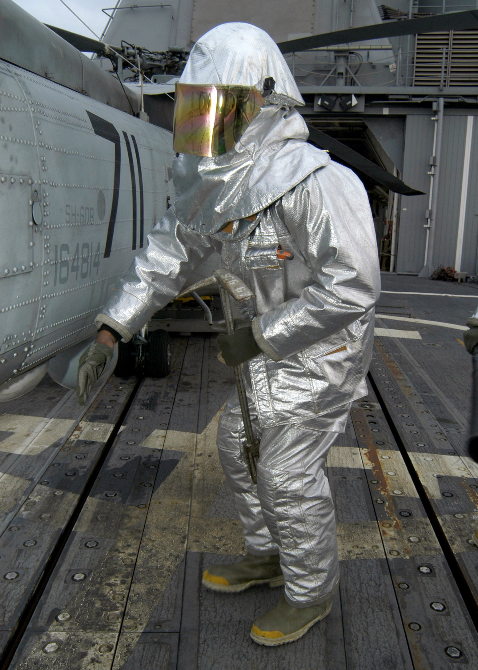

📌 Definition
Technical textiles are fabrics used for functional purposes, not decoration.
👉 Unlike normal clothes:
- Focus = performance (strength, durability, resistance)
- Not fashion
📦 Examples:
- Geotextiles (roads, construction)
- Medical fabrics (surgical gowns)
- Industrial filters
- Fire-resistant fabrics
- Automotive textiles (airbags, seat belts)

⚙️ 2. How the Technical Textile Industry Works
Think of it as a multi-stage manufacturing + compliance-heavy industry
🔄 Process Cycle (Real Industry Flow)
1. Product Requirement / Inquiry
- Customer gives specs:
  - GSM (weight)
  - Strength
  - Coating type
  - Usage (filter, medical, industrial)
👉 This is NOT simple sales — it's spec-driven

2. R&D / Sampling
- Lab creates sample
- Testing happens:
  - Strength
  - Heat resistance
  - Chemical resistance
👉 Multiple iterations happen

3. BOM Creation (Bill of Materials)
- Raw materials defined:
  - Fibers
  - Chemicals
  - Coatings

4. Production Planning
- Machine allocation
- Batch planning
- Process routing

5. Manufacturing
- Weaving / Nonwoven / Knitting
- Coating / Finishing

6. Quality Testing
- Lab tests again
- Compliance check

7. Dispatch & Documentation
- Certificates
- Test reports
- Batch traceability

😖 3. Current Pain Points (Without ERP)
This is where your ERP becomes valuable
🔴 Pain Point 1: Data Scattered Everywhere
- Excel sheets for:
  - Production
  - Inventory
  - Testing
- WhatsApp for communication
👉 Result:
- No single source of truth

🔴 Pain Point 2: No Traceability
- Cannot answer:
  - Which raw material used?
  - Which batch failed?
  - Which machine produced it?
👉 Critical in technical textiles

🔴 Pain Point 3: R&D Not Connected to Production
- Lab creates sample
- Production team doesn’t follow exact specs
👉 Result:
- Quality mismatch
- Customer rejection

🔴 Pain Point 4: Inventory Mismanagement
- Raw materials:
  - Overstock OR shortage
👉 Leads to:
- Delay in production
- Cost increase

🔴 Pain Point 5: Manual Quality Tracking
- Test reports stored as PDFs / papers
👉 No analytics:
- Cannot identify defect patterns

🔴 Pain Point 6: Compliance Issues
- Certifications not tracked properly
👉 Risk:
- Audit failure
- Customer loss

💡 4. Why They NEED ERP
Because this industry is:
✅ Process-driven
✅ Data-heavy
✅ Compliance-heavy
✅ Multi-department
👉 ERP = Central Brain

🧩 5. How ERP Solves Each Problem (Module Mapping)
Now we connect your system 👇

🧪 Module: Technical Textile (Your Custom Module)
🔹 Features:
- Product specification master
- Sample development tracking
- Lab test results
- Version control
👉 Solves:
- R&D mismatch problem

🏭 Module: Production
🔹 Features:
- BOM
- Routing
- Work orders
- Machine allocation
👉 Solves:
- Production planning issues

📦 Module: Inventory
🔹 Features:
- Raw material tracking
- Batch tracking
- Stock alerts
👉 Solves:
- Inventory mismanagement

📊 Module: Quality / Lab Testing
🔹 Features:
- Test reports
- Pass/fail tracking
- Quality history
👉 Solves:
- Manual quality issues

🧾 Module: Sales
🔹 Features:
- Spec-based quotation
- Customer requirements tracking
👉 Solves:
- Miscommunication with customer

📜 Module: Compliance
🔹 Features:
- Certificates
- Audit logs
- Expiry alerts
👉 Solves:
- Compliance risk

🏗️ 6. How Your Approach Looks (Review)
Your architecture:
- React ✅
- Django + DRF ✅
- PostgreSQL ✅
- Modular structure ✅
👉 This is PERFECT for ERP
👉 Especially your:
technical_textile/
production/
inventory/
reports/
💯 Strong Points:
- Scalable
- Modular
- Industry-specific customization possible

⚠️ 7. Suggested Improvement (Important)
Add This:
1. 🧬 Traceability System (Very Important)
- Batch → Raw Material → Machine → Operator
👉 This is must-have in technical textile

2. 📊 Version Control for Specs
- Same product → multiple versions

3. 🔗 Link Everything
- Inquiry → Sample → BOM → Production → Testing → Dispatch
👉 This is your ERP backbone

🧠 Final Understanding (Very Important for You)
👉 Technical textile ERP is NOT normal ERP
It is:
✔ Spec-driven
✔ Lab-integrated
✔ Traceability-heavy
✔ Compliance-based

🚀 Next Step
Now we go deeper (your ERP building phase):
👉 Next I recommend:
We design the Technical Textile module in detail (FSD level)
We can create:
- Tables
- Fields
- Workflow
- API structure

Great study material. Let me do a proper gap analysis — what you built vs what the industry actually needs.

Gap Analysis — SASI ERP vs Technical Textile Industry
✅ Pain Points Already Covered
Industry Pain Point | What You Built | Status
Data scattered in Excel | Centralized ERP — all modules in one system | ✅ Solved
No batch traceability | Batch Traceability page (Medical module) | ✅ Solved
Manual quality tracking | Testing Lab — records actual vs spec values | ✅ Solved
Compliance not tracked | Regulatory Compliance + expiry alerts | ✅ Solved
R&D not tracked | R&D Projects module | ✅ Solved
Sample development | Sample Management — prepared/sent/approved | ✅ Solved
Performance specs | GSM, tensile, elongation, tear strength per product | ✅ Solved
Inventory mismanagement | Stock list + low stock alerts | ✅ Solved
CAPA management | Full CAPA module with open/close | ✅ Solved

❌ Gaps — What Is Missing
Gap 1 — Inquiry to Quotation (Spec-Based Sales)
What industry does: Customer sends specs (GSM, strength, coating) → company responds with quotation
What you have: Sales Orders (just price + quantity)
What's missing: Customer Inquiry form with spec fields → link to quotation → link to sample development → link to order

Gap 2 — Full End-to-End Workflow Link
What industry needs:
Customer Inquiry
→ Sample Development
→ Sample Approved
→ BOM Created
→ Work Order
→ Testing Lab
→ Dispatch
What you have: Each step exists as a separate page but they are NOT linked to each other. No single screen shows the full journey of one order.

Gap 3 — Machine & Process Routing
What industry does: Each product goes through specific machines in specific order (weaving → coating → finishing)
What's missing:
- Machine master (machine name, capacity, status)
- Process routing (product X → machine A → machine B → machine C)
- Machine-level production tracking

Gap 4 — Spec Version Control
What industry does: Same product has V1, V2, V3 specs as customer revises requirements
What's missing: Performance Specs have no version history — editing overwrites the old spec

Gap 5 — Technical Textile Traceability
What you built: Medical textile batch traceability (raw material → QC → dispatch)
What's missing for Technical: Link batch → which machine → which operator → which raw material lot → which test results

Gap 6 — Costing Module
What industry needs: How much does it cost to make 1 meter of Product X?
What's missing: BOM costing (raw material cost + machine time + labor = product cost), margin calculation

Gap 7 — Customer Specification Document
What industry sends customers: A formal document showing the exact spec of what was made — linked to test results and batch number
What's missing: No document generation (PDF) — everything is screen-only

📊 Overall Score
Category | Coverage
Core ERP (inventory, purchase, sales, finance, HR) | 90%
Technical Textile specific | 65%
Medical Textile specific | 85%
End-to-end workflow linking | 30%
Machine & routing | 0%
Costing | 0%
Document generation (PDF) | 0%

🎯 My Recommendation — Build in This Order
Phase 2 (sell to first customer):
- Inquiry → Quotation module (spec-based — this is your sales differentiator)
- Workflow linking — connect Sample → BOM → Work Order → Test Result in one view
- Machine master — simple machine list with status
Phase 3 (after first revenue): 4. Process routing per product 5. Spec version control 6. Technical traceability (batch → machine → operator) 7. Costing module
Phase 4 (premium feature): 8. PDF generation — TDS, test reports, traceability certificates

Bottom Line
Your ERP solves the foundation well — data centralization, compliance, quality, traceability basics.
The biggest gap is the end-to-end workflow link — right now each module is an island. A customer visiting your demo will ask: "Can I see where my order is right now, from inquiry to dispatch?"
That single view — the Order Journey — is what separates a good ERP from a great one.
Want to build the Inquiry → Quotation module next, or the workflow linking view first?

